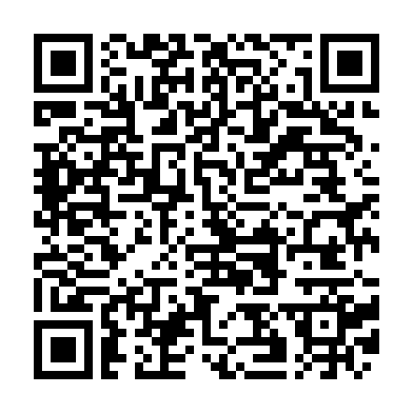
Fax: 0049 5231 20505
Association of Cereal Research
Schuetzenberg 10

D-32756 Detmold

Registration
Name: _____________________________ First Name: ______________________________
Name: _____________________________ First Name: ______________________________
Name: _____________________________ First Name: ______________________________

Institute/Company: ____________________________________________________________

Street/PO-Box: ______________________________________________________________

Post Code/City: ______________________________________________________________

Phone: ________________________________ Fax: _________________________________

Mail: _______________________________________________________________________

Accommodation (Please reserve a room before October 11th 2019*)
* Confirmation will be forwarded directly by the hotel.

Name __________________________________ First Name ____________________________

Arrival ___________ Depature __________ Nights _____ Single Room Double Room

Name __________________________________ First Name ____________________________

Arrival ___________ Depature __________ Nights _____ Single Room Double Room

Name __________________________________ First Name ____________________________

Arrival ___________ Depature __________ Nights _____ Single Room Double Room

Room Category (Single Room): A (up to 120 €) B (up to 70 €)

If the requested category is not available, please arrange accommodation in category ________

Travel by Car: yes no

__________________________________ ___________________________________
Date Signature

